**Design & Technology**

**

**Ease of manufacture**

**Materials required for questions**

* Pencil
* Rubber
* Calculator

**Instructions**

* Use black ink or ball-point pen
* Try answer all questions
* Use the space provided to answer questions
* Calculators can be used if necessary
* For the multiple choice questions, circle your answer

**Advice**

* Marks for each question are in brackets
* Read each question fully
* Try to answer every question
* Don’t spend too much time on one question

**Good luck!**

**Q1.** How do ribs and webbing improve product design?

**A** They make products heavier

**B** They increase strength while reducing material thickness

**C** They require additional assembly steps

**Q2.** What is the main advantage of snap fittings?

**A** They eliminate the need for screws/adhesives

**B** They make disassembly impossible

**C** They increase production costs

**Q3.** How do pre-made components aid manufacturing?

**A** They reduce custom fabrication time

**B** They slow down production lines

**C** They increase material waste

**Q4.** Which design feature reduces assembly labour?

**A** Hand-carved joints

**B** Custom weld points

**C** Snap-fit components

**Q5.** State the function of each of the features below **(2 marks)**

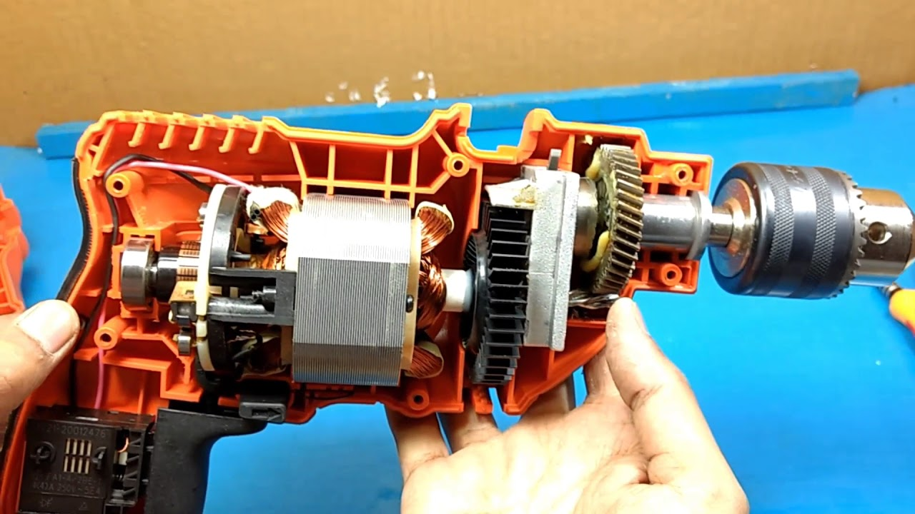

Moulded boss

Rib

Moulded boss

Rib

**Answers**

**Q1**. B

**Q2**. A

**Q3**. A

**Q4**. C

**Q5**.

Moulded boss

* To help locate two halves of an injection moulded casing.
* To allow a ‘self-tapping’ screw to be used to secure two halves of an injection moulding casing together.

Rib

* To provide strength and rigidity to an injection moulded casing.
* To reduce the volume of plastic needed by allowing for a thinner wall thickness